ModelMuse with Support for PEST – Beta 3

# Introduction

The previous Beta version of ModelMuse allowed the user to define parameters and observations for use with PEST. It also came with utility programs that could be used to extract the simulated values from the MODFLOW output and provide them to PEST. Another utility program helped with applying the parameter values to boundary conditions.

This version of ModelMuse goes beyond the previous version in several ways.

* Parameters can now be applied to array data such as hydraulic conductivity rather than just with boundary conditions.
* ModelMuse can create a PEST control file and start PEST so that it estimates parameter values.
* Some of the utility programs have been modified to better perform their functions.
* It is now possible to define comparison observations among the built-in observation types in MODFLOW-2005.

There are some important limitations in the current beta version of ModelMuse.

* Pilot points are not yet supported; For now, parameters can only be applied to zones.
* The only PEST mode that is currently supported is estimation; it does not currently support prediction, regularization or pareto modes.
* ModelMuse does very little error-checking with respect to PEST data.
* ModelMuse does not necessarily supply appropriate default values for PEST input variables.
* Parameters for boundary conditions are limited to those defined in MODFLOW-2005. Thus, for example, parameters for the SFR package in MODFLOW 6 are not available although parameters for drain conductance in MODFLOW 6 are available.
* The RunModel batch file run by PEST does not delete some files model input and output files before recreating them by running the rest of the batch file.
* The utility programs and the PLPROC program must be in the model directory.
* There is no built-in help for PEST yet.

Future releases will address these deficiencies.

# Activating PEST

To activate pest, select “Model|PEST Properties” and check the “Use PEST” checkbox. You must also specify the directory in which you have installed PEST. (You install PEST by unzipping the PEST distribution file downloaded from <https://pesthomepage.org/>.) Note that the “Help” button in this dialog box doesn’t work yet. You can also specify the template character used in PEST templates. The formula marker serves a similar function to the template character in the utility program EnhancedTemplateProcessor. For now, you can ignore the “Show pilot points” check box and the “Pilot point spacing” edit box because pilot points are not yet supported. Click OK to close the dialog box and activate PEST.

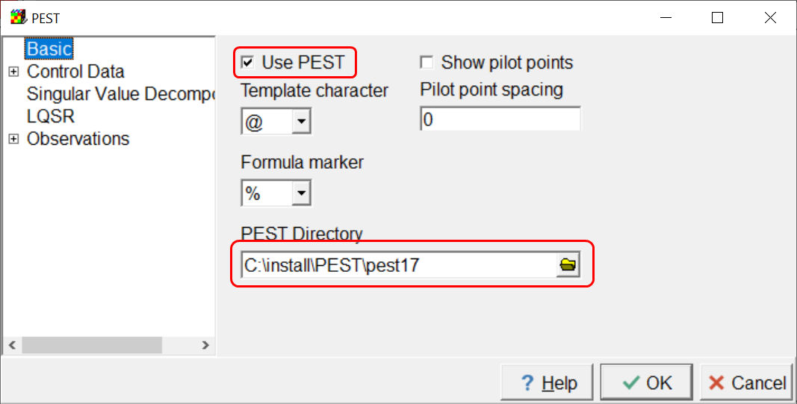

# Defining Parameters

There are two places where you can define parameters: the “Model|Manage Parameters” dialog box and the “Model|Packages and Programs” dialog box. The latter is applicable to MODFLOW models but not SUTRA models. The “Packages and Programs” dialog box will not be discussed here because it still works the way it did previously with respect to parameters. The “Manage Parameters” dialog box is the main way you work with parameters for PEST.When PEST is active, there are four tabs: “Parameters”, “Parameter Groups”, “Group Assignments”, and “Tied Parameters”. There is also an “Import Pval file” button at the bottom of the dialog box. After parameter estimation has been completed, you can use this to import the updated parameter values so you can visualize the final distribution of model input values.

## Parameters Tab

The Parameters tab has a table with multiple columns. You can add new parameters by increasing the “Number of parameters”. You can delete parameters by selecting a row and clicking the “Delete” button. The first column lists the parameter names. Each parameter name must be unique. The parameter names must be unique. PEST and MODFLOW both place limitations on the length and characters that can be used in parameter names. The dialog box enforces those restrictions. The second column is always grayed out; it is for informational purposes only. In MODFLOW models it indicates with which package(s) the parameter can be used. The third column indicates the type of parameter. ~~For MODFLOW-2005 models this can be any of the parameter types defined in MODFLOW-2005.~~ However, there is also an additional type labeled “PEST”. **At present, the PEST parameter type can only be used with array data such as hydraulic conductivity.** In the future, it may be possible to use it in other ways. The next column, “Value”, defines the initial value of a parameter assigned by ModelMuse. The “Multiplier Array” and “Zone Array” columns apply only to MODFLOW parameters for certain packages. The remaining columns are new and are specific to PEST. The “Pilot Points” column contains checkboxes where applicable. In the future, it will determine whether pilot points will be used with a specific parameter. For now, ignore it because pilot points are not supported in this version of ModelMuse. The remaining columns all refer to variables defined in the PEST control file. Refer to the PEST documentation for the meanings of specific variables.

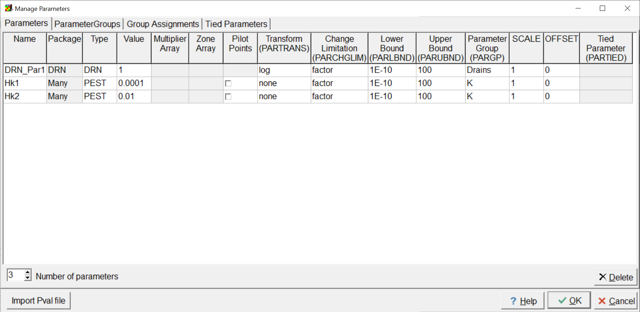

## Parameter Groups Tab

The “Parameter Groups” tab contains a table in which the user defines the parameter groups. The column headings indicate the names of the PEST input variables in the PEST control file. Refer to the PEST documentation for the definitions of these variables. At present, the default values assigned to these variables are often inappropriate. In particular, **the user should be sure to assign good values for DIRINC and FORCEN.**

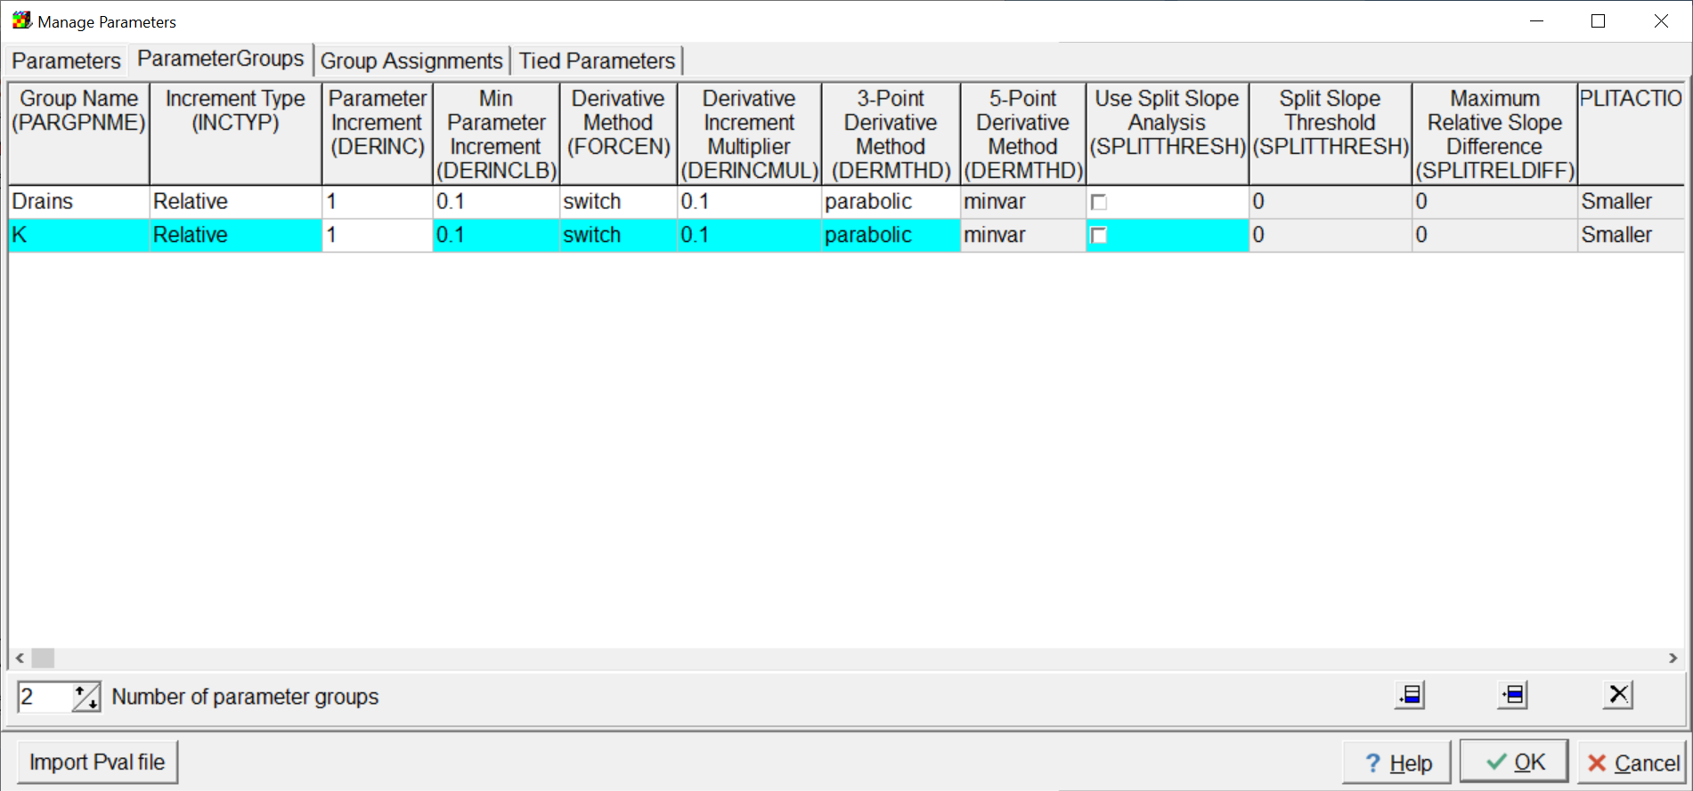

## Group Assignments Tab

The “Group Assignments” tab can be used to assign multiple parameters to a parameter group. The tab contains a tree control with parameter groups as the first level items and parameters as the second level items. Initially, all the parameters are not assigned to any parameter group and will be listed under “(none)”. To move parameters to new parameter groups, select them and drag them to a new group. You can select a single parameter by clicking on it. One way to select multiple parameters is to select one parameter and then hold down the “Shift” key and clicking on another parameter. All the parameters between them will become selected and can then be dragged to a new parameter group. Another way to select multiple parameters is to hold down the “Ctrl” key and click on a parameter. The parameter will toggle between selected an unselected. **Reassigning a parameter to a parameter group on this tab will also reassign it on the Parameters tab. However, the reverse is not the case a present.** This is an issue to be addressed in the future. **Another issue to be addressed in the future is that if you rename a parameter, the new name is not used in the Group Assignments tab.**

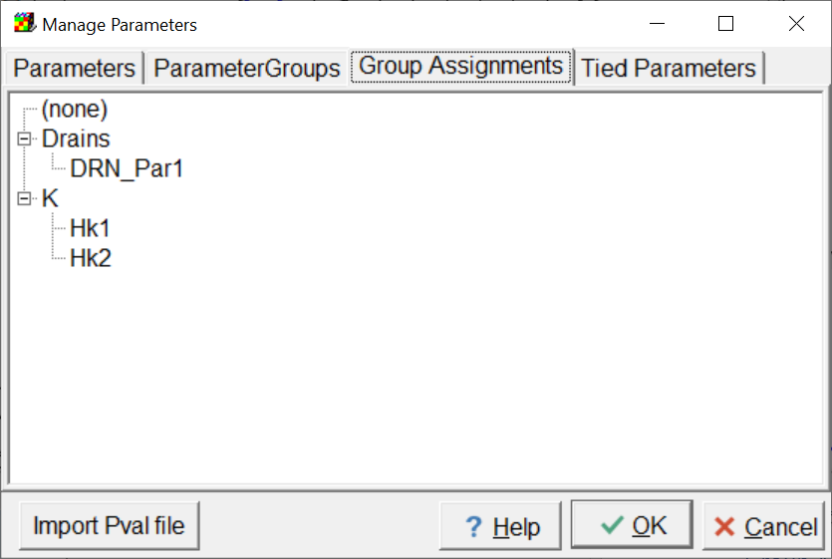

## Tied Parameters Tab

A tied parameter is on that whose value is defined through another parameter. The ratio between the tied parameter value and the value of the parameter to which it is tied is kept at a constant ratio when PEST estimates parameters. The Tied Parameters tab is used to assign multiple tied parameters at once.

The tab contains a tree control with untied parameters as the first level items and tied parameters as second level items under their parent items. You can select one or more items in the same way as on the Group Assignments tab and then drag them to another parameter to tie them to it. You can also drag them away from any other parameter to untie them. Change made here will also be made on the Parameters tab. **However, the reverse is not the case. Changes made on the Parameters tab do not change where the parameters are shown on the Tied Parameters tab until the user clicks OK and then reopens the Manage Parameters dialog box. In addition, new parameters are not displayed on the Tied Parameters tab until the user clicks OK and then reopens the Manage Parameters dialog box. These issues will be addressed in the future.**

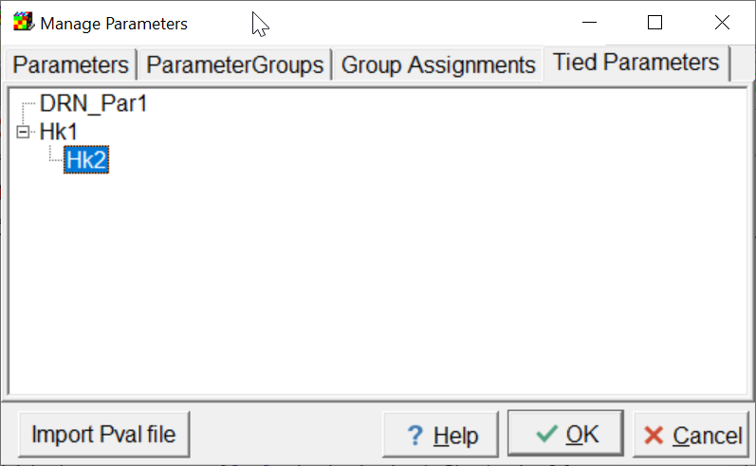

# Assigning PEST Parameters

The user assigns parameters for boundary conditions in MODFLOW in the same way as in the released version of ModelMuse and is not addressed here. If the parameter type of a parameter is PEST it can be used to assign values to certain required data sets. (They can not be used to assign values to data sets you define yourself.)

## Specify Data Sets for PEST Parameters

The user chooses which data sets will be affected by PEST parameters in the “Data|Edit Data Sets” dialog box. In the dialog box select one of the Required data sets except those under “Layer Definition”. If the data set type is “Real” (meaning the data in the data set consists of real numbers) a “Parameters tab will be available. If the “Parameter used” check box on it is checked, a new data set will be created when the user clicks the OK button.

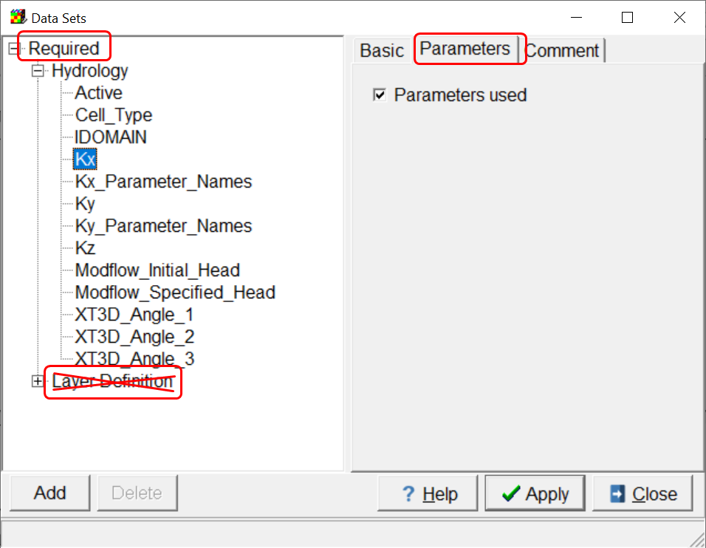

The new data set name will terminate with “_Parameters_Names.” The beginning of the data set name refers to the name of the data set to which the parameters will be applied. For example, in the illustration below, the “Kx_Parameter_Names” data set will be used to apply PEST parameters to the Kx data set.

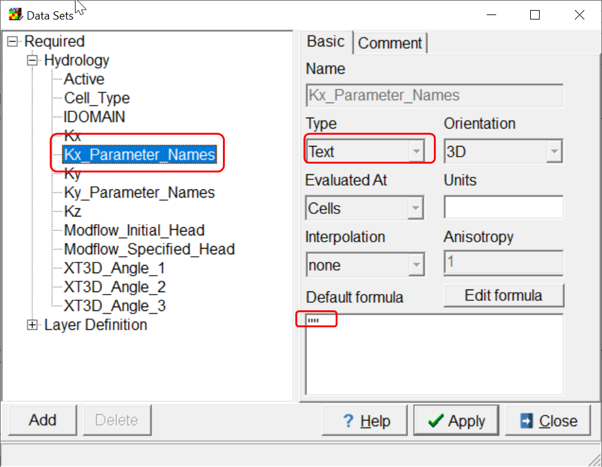

## Applying Parameters

The default formula for a Parameter_Names data set will be a pair of double quotes defining an empty text variable. If you want to apply a parameter to an entire data set, specify its name between double quotes in the default formula for the Parameter_Names data set. You could also define a formula that returns different parameter names in different locations. However, it is usually easier to use objects to define the spatial variation in parameters. The ultimate value assigned to a a data set will be the parameter value multiplied by the value that would be assigned to the data set if parameters were not involved. For example, suppose you had assigned Kx a value of 1E-5 and applied a PEST Parameter whose value was 0.3. The final value assigned to the data set would be 3E-6.

ModelMuse does apply PEST parameters to data sets when evaluating them if PEST is active. Because of this, **you need to be careful how you use formulas for data sets especially if both data sets will have PEST parameters assigned**. For example, suppose I define a PEST parameter and use it for both the Kx and Ky data sets. If I leave the default formula for Ky set to “Kx”, this could result in unreasonable values applied to the Ky data set. Here’s what could happen. I set the parameter to 1E-5 and apply it to both Kx and Ky. If the default formula for Kx is 2, the value assigned to Kx would be 2.0 x 1E-5 =2.0E-5. Because the default formula for Ky is Kx, the value assigned to Ky would be the value assigned to Kx (2E-5) times the parameter value (1E-5) so the final value assigned to Ky would be 2.0E-5 x 1E-5 = 1E-10. **This probably would not be the intended outcome.**

# Observations

The methods used to define observations have hardly changed from the previous Beta versions. See the documentation for Beta Releases 1 and 2 for more information. The one important change is that it is now possible to define observations comparisons for the built-in observations in MODFLOW-2005. For example, if you have two head observations at different locations, it is now possible to use the difference in head between them as an observation. You do this in the “Model|Edit Observation Comparisons” dialog box.

# Observation Groups

Observation groups are defined in the “Model|Pest Properties” dialog box on the Observation Groups pane. At present, I suggest only defining the observation group names. Group targets only apply to the PEST regularization mode which is not yet supported by ModelMuse.

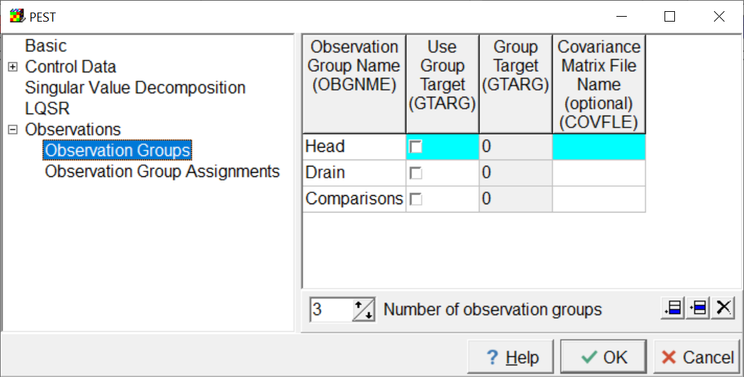

Each observation must be assigned to an observation group. This is done on the Observation Group Assignments pane. This pane contains a tree control with observations groups as first level items and observations as second level items. You can select observations in the same as you could select parameters in the Manage Parameters dialog box. Once one or more parameters are selected, you can drag them to a different parameter group. **Be sure you assign all observations to observation groups before attempting to run PEST.**

# Running PEST

Most of the data for the PEST control file is specified in the “Model|PEST Properties” dialog box. The PEST input variables are defined in the PEST documentation. A few things, such as the number of parameters and number of observations are assigned automatically. Parameter and Parameter group definitions are defined in the Model|Manage Parameters dialog box. After specifying control data information you should be nearly ready to run PEST.

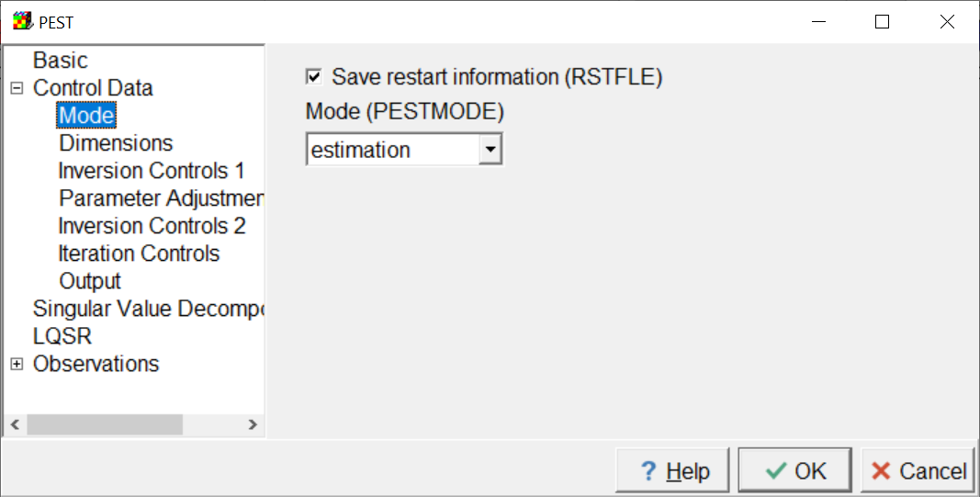

There is one other thing to do before running PEST and that is to make sure that the utility programs that come with this Beta version of ModelMuse are in the same directory as the model input files. You should also make sure PLPROC is in the same directory as the model input files. Then select File|Export|<model type> where model type is one of the MODFLOW or SUTRA model types. The file for running the model will also run one or more of the utility programs. One utility programs will create PEST instruction files for extracting output from the model output files. Another one might create templates used to create scripts for PLPROC. It is important that the model run to completion because the instruction file for extracting the simulated values form the model output requires that the model output be present. Another thing that will happen is that a batch file name “RunModel.bat” will be created. PEST will use this batchfile to run the model.

After the model has run, you can select “File|Export|Run PEST”. This creates the PEST control file and a batch file named “RunPEST.bat.” The batch file will start PEST in a command line window which will stay open in PEST finishes running.

# Examples

This Beta version of ModelMuse comes with three examples that illustrate some aspects of defining parameters and observations in ModelMuse and running PEST. There is one example each for MODFLOW 6, MODFLOW-2005 and SUTRA. For each of them, you should be able to run the model and then have PEST estimate parameters defined in the model. However, don’t expect too much from these examples. They are meant to test that ModelMuse can get PEST to estimate parameters in a model but they don’t represent anything real. You can look at them for examples of how to go about defining parameters and observations but don’t expect more from them than that.

## MODFLOW 6

PestTest.gpt is a MODFLOW 6 model. There are three parameters defined. One parameter is a boundary condition parameter for the Drain package. The other two are PEST parameters used with the Kx and Ky data sets. There is a single drain boundary in the lower right corner of the model to which the drain parameter is applied. There is also a drain observation for this boundary. The model domain is split diagonally into two regions and one of the parameters is applied to each region through all three layers. There are three head observations (H1, H2, and H3) defined by point objects. The difference between H1 and H2 is also defined as an observation in the “ModelEdit Observation Comparisons” dialog box.

## MODFLOW-2005

MF2005.gpt is a MODFLOW-2005 model. It has a single MODFLOW-2005 HK parameter defined for the LPF package. There are no PEST parameters or boundary condition parameters defined. There are MODFLOW-2005 built-in flow observations defined for all the MODFLOW-2005 flow observation package. These are defined in the Model|Manage Flow Observations dialog box. There are also two flow observations defined at different times but at the same location. A comparison between them is defined in the “ModelEdit Observation Comparisons” dialog box.

## SUTRA

Rocky2D_Irregular.gpt is a SUTRA 3.0 model. It has two PEST parameters which are used to specify the Porosity in the northern and southern half of the model respectively. There are other data sets for which “Parameters used” has been checked in the “Data|Edit Data Sets”. However, the parameter names assigned to them don’t correspond to any actual parameters so no parameters will actually be used with them. There are two head observations and a concentration observation. There is a fluid flow observation defined in the “Model|Manage SUTRA Boundary Observations” dialog box. This is similar to the “Model|Manage Flow Observations” dialog box with MODFLOW-2005 models.